

Via Fax: (573)751-8115
Mr. Joshua Cox
Missouri Department of Revenue
General Counsel’s Office
Post Office Box 475
Jefferson City, Missouri 65105-0475

RE: Petitioner: Tyler Crowley
Docket No.: STLO0485
Case No.: AD23013714
DLN: 204B170013
Hearing Date: April 29, 2024

Dear Mr. Cox:

Petitioner would like the Hearing Officer to review the documents on file with the Department of Revenue and make a decision based on these documents, having no additional evidence to submit. Counsel previously filed a continuance request in error. We apologize for any inconvenience.

Please call me right away if there is an issue with this request or if you should have any questions. Thank you for your assistance and your courtesy.

Sincerely,

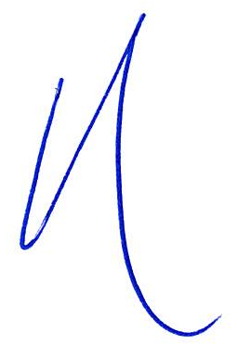
/s/Heidi Leopold_____________________
Heidi Leopold #40473
75 West Lockwood Avenue, Suite 250
Webster Groves, Missouri 63119
Telephone: 314-561-9690
Facsimile: 314-596-0658
Email: john@jcsattorney.com
heidi@jcsattorney.com
Attorney for Petitioner
HLL/taw
facsimile

